MATH 243 — Probability and Statistics
Measures of Central Tendency: Mean, Median, Quartiles, Mode
Lesson notes · Exam approach · TF practice with solutions · Quick notes (Statistics portion)

How to Read These Notes
EXAM FOCUS | Exam importance, where it appears in the TF collection
MEMORIZE | Rules, tables and formulas to memorize
TRAP | Common mistakes and exam traps
EXAM-READY ANSWER | Model wording you can write in the exam
NOTE | Extra explanation / clarification
Grey box, monospace | Code, worked tables, derivations and hand-drawn sketches
Centered grey box | Formula to remember / final numerical result
Purple heading / ✔ green | Practice questions / their solutions

Contents
Exam Map — What the TF Papers Ask — missing frequencies and graphical median
Lesson 5 — Arithmetic, Geometric and Harmonic Means — direct and short-cut (step-deviation) method
Lesson 6 — Median, Quartiles, Deciles, Percentiles and the Ogive — positional averages, graphical median
Lesson 7 — Mode, Empirical Relation and Missing Frequencies — Δ formula, Mode = 3Md − 2Mean, two unknown frequencies
Quick Notes — Central Tendency — revision bullets
NOTE Page numbers refer to 2. Central Tendency.pdf (26 pp.), written as p. n. "TF p." = merged question PDF page. Mean, median and mode of grouped data are also needed inside every skewness question (Skewness, Moments and Kurtosis note).

Exam Map — What the TF Papers Ask
Session (paper) | Questions answered by this note [lesson]
2021-22 (MATH 245)  TF p. 44 | Q5(a) Monthly wages 1900-2400 (7 classes): suitable diagram, median from graph and formula; workers earning 2000–2170 (18) [L6]
2015-16 (MATH 241)  TF p. 15 | Q6(a) Incomplete distribution, N = 1000, median 415: missing frequencies, modal value, shape (18) [L7]
2014-15 (MATH 241)  TF p. 10 | Q6(a) Incomplete distribution, N = 1000, median 413.11: find the two missing frequencies and the mode (17) [L7]

EXAM FOCUS 3 direct questions (53 marks), but grouped mean/median/mode appear inside every skewness and CV question too, so this deck supports about a third of the Statistics marks. The "missing frequencies from the median" problem was asked in 2014-15 and 2015-16 with the same table; the ogive-median problem in 2021-22. Know the median and mode formulas by heart.

Lesson 5 — Arithmetic, Geometric and Harmonic Means
pp. 1–6, 22
A measure of central tendency is a single value around which the data tend to cluster; it represents the whole data and makes comparison easy. Types: arithmetic mean, median, mode, geometric mean, harmonic mean (p. 1).
Ungrouped: x̄ = Σx_{i}/N; frequency distribution: x̄ = Σf_{i}x_{i}/N
Short-cut: x̄ = A + (Σf_{i}d_{i}/N) × h, d_{i} = (x_{i} − A)/h
A = assumed mean (the middle mid-value), h = class width, x_{i} = mid-values, N = Σf.
Marks | Mid x | f | d = (x − A)/h | fd
0–20 | 10 | 4 | −3 | −12
20–40 | 30 | 26 | −2 | −52
40–60 | 50 | 22 | −1 | −22
60–80 | 70 | 10 | 0 | 0
80–100 | 90 | 9 | 1 | 9
100–120 | 110 | 6 | 2 | 12
120–140 | 130 | 3 | 3 | 9
Total |  | N = 80 |  | Σ = −56

Marks of 80 students (p. 4): x̄ = 70 + (−56/80) × 20 = 56. Other slide examples: incomes of 10 employees Σ = 44,940 → Tk 4494; discrete table → 320/25 = 12.8; 0–50 table → 25 + (−2/50)10 = 24.6; heights (boundaries 129.5–164.5) → 147 + (−33/100)5 = 145.35; practice answers 69.18 and 51.75.
G.M. = antilog(Σf log x / N); H.M. = N / Σ(f/x)
TRAP With limits like 130–134, 135–139 use boundaries 129.5–134.5 … for the median/mode L and h, but the mid-values (132, 137, …) are the same either way.

Lesson 6 — Median, Quartiles, Deciles, Percentiles and the Ogive
pp. 7–18

1. Median (pp. 7–13)
Ungrouped: arrange in order; N odd → ((N + 1)/2)-th value; N even → mean of the (N/2)-th and (N/2 + 1)-th values (weights 39 … 61 → 44; ten mothers → (43 + 44)/2 = 43.5).
Median = L + [(N/2 − p.c.f.)/f] × h
L = lower boundary of the median class (where the (N/2)-th value lies), p.c.f. = cumulative frequency before it, f = its frequency, h = width.
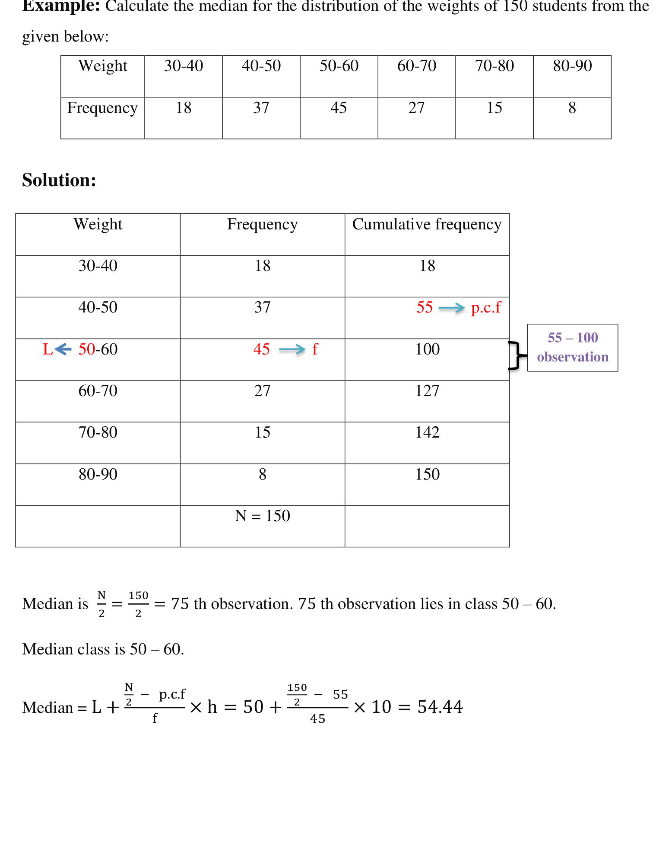
Figure 6.1 — Locating the median class (75th value) and applying the formula (p. 9)
Slide answers: weights 54.44; overtime 20 + (50 − 31)/35 × 5 = 22.71 hrs (50 % work up to 22.71 hrs); profits 30 + (62.5 − 40)/36 × 10 = 36.25 crore; heights 144.5 + (50 − 48)/24 × 5 = 144.92; days absent 10 + (327.5 − 224)/241 × 5 = 12.15; practice 49.09 and 47.58.
NOTE The profit example (p. 11) prints 36.5; the formula gives 30 + 22.5/36 × 10 = 36.25 crore.

2. Quartiles, Deciles, Percentiles (pp. 15–18)
Q_{i} = L + [(iN/4 − p.c.f.)/f] h, D_{i}: iN/10, P_{i}: iN/100
Profits of 100 companies: Q₁ = 40 + (25 − 12)/18 × 10 = 47.22; Q₂ = 50 + (50 − 30)/30 × 10 = 56.67; Q₃ = 60 + (75 − 60)/15 × 10 = 70 lakhs (25 % earn 47.22 lakhs or less). Overtime Q₁ = 18.5.

3. Graphical Median from the Ogive (textbook; asked 2021-22 Q5(a))
Draw the less-than ogive (upper boundary, cumulative frequency). Mark N/2 on the y-axis, go horizontally to the curve and drop to the x-axis: that x is the median. (Drawing both less-than and more-than ogives, they cross at the median.)

Exam Approach
1. Cumulative frequency column; position N/2 (or iN/4); locate the class.
2. Substitute L, p.c.f., f, h in the formula; one line of arithmetic.
3. Interpret: "50 % of … are below …".

Practice — Lesson 6
(a) Actual — 2021-22 Q5(a) (TF p. 44).
(a) Monthly wages of workers: 1900–1950: 6, 1950–2000: 10, 2000–2050: 22, 2050–2100: 30, 2100–2150: 16, 2150–2200: 12, 2200–2400: 15. Draw a suitable diagram, read the median from the graph and verify it by formula. How many workers earned monthly wages between 2000 and 2170 Tk? (18)

✔ Solution
Wages | f | Less than | c.f.
1900–1950 | 6 | 1950 | 6
1950–2000 | 10 | 2000 | 16
2000–2050 | 22 | 2050 | 38
2050–2100 | 30 | 2100 | 68
2100–2150 | 16 | 2150 | 84
2150–2200 | 12 | 2200 | 96
2200–2400 | 15 | 2400 | 111

Suitable diagram: the less-than ogive — plot (1900, 0), (1950, 6), (2000, 16), (2050, 38), (2100, 68), (2150, 84), (2200, 96), (2400, 111) and join. (The last class is wider, which an ogive handles without adjustment; a histogram would need height 15/4 per 50 Tk.)
N = 111; N/2 = 55.5 → on the ogive, across from 55.5 the curve is at about Tk 2079.
Formula: median class 2050–2100 (c.f. 38 → 68):
Median = 2050 + (55.5 − 38)/30 × 50 = 2050 + 29.17 = 2079.17 Tk
Between 2000 and 2170: 22 + 30 + 16 + (2170 − 2150)/50 × 12 = 68 + 4.8 = 72.8 ≈ 73 workers
(graphically: c.f. at 2170 ≈ 88.8 minus c.f. at 2000 = 16 → 72.8)

Lesson 7 — Mode, Empirical Relation and Missing Frequencies
pp. 19–26
Mode = L + [Δ₁/(Δ₁ + Δ₂)] × h
Δ₁ = f_{modal} − f_{pre-modal}, Δ₂ = f_{modal} − f_{post-modal}
Empirical relation (moderately skewed): Mode = 3 Median − 2 Mean
Weights 30–90 (f 18, 37, 45, 27, 15, 8): Mode = 50 + 8/(8 + 18) × 10 = 53.08. Marks (7, 32, 56, 106, 180, 164, 86, 44): Mode = 40 + 74/(74 + 16) × 10 = 48.22. Sales practice: 64.4. Ungrouped: the most frequent value (5, 8, 10, 8, 5, 8 → 8).
Empirical-relation examples (pp. 23–25): weights median 54.44, mode 53.08 → mean = (3 × 54.44 − 53.08)/2 = 55.12; marks mean 56, median 40 + (40 − 30)/22 × 20 = 49.09 → mode = 3(49.09) − 2(56) = 35.27; heights mean 145.35, median 144.92 → mode 144.06.

Missing Frequencies (p. 26 practice 2)
With the total N and the median (and/or mode) given, write one equation from Σf = N and one from the median (or mode) formula, then solve. Practice 2 (median 33.5, mode 34, N = 230): f = 60, 100, 40.

Exam Approach
1. Let the unknowns be f₁, f₂; Σf = N gives f₁ + f₂ = …
2. Decide which class contains the given median; write the median equation with p.c.f. containing f₁ if it lies above.
3. Solve, round to whole numbers, check the median, then find the mode by the Δ formula and comment on the shape (compare mean, median, mode).

Practice — Lesson 7
(a) Actual — 2014-15 Q6(a) (TF p. 10). (b) Actual — 2015-16 Q6(a) (TF p. 15).
(a) Incomplete distribution with total frequency 1000 and median 413.11: 300–325: 5, 325–350: 17, 350–375: 80, 375–400: ?, 400–425: 326, 425–450: ?, 450–475: 88, 475–500: 9. Estimate the missing frequencies and find the mode. (17)
(b) The same table with median 415. Estimate the missing frequencies, find the modal value and comment on the shape of the distribution. (18)

✔ Solution
(a) Let f₄ = x (375–400) and f₆ = y (425–450).
Σf = 5 + 17 + 80 + x + 326 + y + 88 + 9 = 525 + x + y = 1000 → x + y = 475
Median 413.11 lies in 400–425; p.c.f. = 5 + 17 + 80 + x = 102 + x; N/2 = 500
413.11 = 400 + (500 − 102 − x)/326 × 25 → 398 − x = 170.954 → x ≈ 227, y = 475 − 227 = 248
Mode: modal class 400–425, Δ1 = 326 − 227 = 99, Δ2 = 326 − 248 = 78
Mode = 400 + 99/(99 + 78) × 25 = 413.98

(b) Let f₄ = x (375–400) and f₆ = y (425–450).
Σf = 5 + 17 + 80 + x + 326 + y + 88 + 9 = 525 + x + y = 1000 → x + y = 475
Median 415 lies in 400–425; p.c.f. = 5 + 17 + 80 + x = 102 + x; N/2 = 500
415 = 400 + (500 − 102 − x)/326 × 25 → 398 − x = 195.6 → x ≈ 202, y = 475 − 202 = 273
Mode: modal class 400–425, Δ1 = 326 − 202 = 124, Δ2 = 326 − 273 = 53
Mode = 400 + 124/(124 + 53) × 25 = 417.51

Mean (short-cut, A = 412.5) = 413.57. Mean 413.57 < median 415 < mode 417.51: the distribution is slightly negatively skewed (longer tail to the left), though nearly symmetric.

Quick Notes — Central Tendency
Revision points for Lessons 5–7.

L5 · Means
- x̄ = A + (Σfd/N)h, d = (x − A)/h. Marks 80 students → 56; heights → 145.35.
- G.M. = antilog(Σf log x/N); H.M. = N/Σ(f/x).

L6 · Median and Quartiles
- Median = L + (N/2 − pcf)/f × h; Q_{i}: iN/4; D_{i}: iN/10; P_{i}: iN/100.
- Ogive: across from N/2 to the curve, down to x. Wages: median 2079.17; 2000–2170: 72.8 ≈ 73.

L7 · Mode and Missing Frequencies
- Mode = L + Δ1/(Δ1 + Δ2) × h; Mode = 3Md − 2Mean.
- Median 413.11 → 227, 248, mode 413.98; median 415 → 202, 273, mode 417.51 (slight negative skew).

